Ministry of Labour, Health and Social Affairs of Georgia



E-Health

Vital Registration Module

Health Management Information System

June
2014

Contents

Introduction 3
1. User Authorization 3
2. Navigation Pane 5
3. Birth Certificate 6
4. Death Certificate 14
5. List of Deceased Persons 27
6. List of Newborns 30

Introduction
The Vital Registration Module represents a part of the Health Management Information System (HMIS). The purpose of the module is to ensure online registration of births and deaths countrywide. It will enable the Ministry of Labour, Health and Social Affairs of Georgia (MoLHSA) and other stakeholders to receive and analyze real-time information.

The Vital Registration Module can be found on the HMIS E-Health portal at the following address: ehealth.moh.gov.ge

User Authorization
The user must log into the system using his/her username and password (the information is provided by the system administrator).
Enter your username and password and click on the Enter button (see Fig.1).

Figure 1
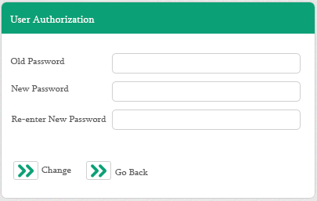

Any user must follow the following instructions to change his/her password:
Click on the  button to open the Change Password window. Enter your current password, followed by the current and new passwords. The user must re-enter password to avoid mistakes. Click on the Save button to save changes made to the database (Fig. 1.1)

Figure 1.1
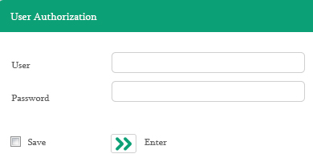
The user automatically moves to the interface of the Vital Registration Module and in the relevant window s/he selects the healthcare facility on behalf of which s/he registers the specific birth/death (Fig. 2). It is noteworthy that only contracted healthcare facilities are displayed in the drop-down list.
Figure 2
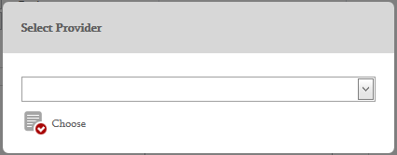

Navigation Pane
The navigation pane includes the following categories (Fig. 2):

Figure 3
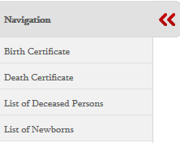

- Birth Certificate – interface for registration of newborns, their parents, deliveries and other additional information
- Death Certificate – interface for registration of deceased persons, causes of death and additional information related to death
- List of Deceased Persons – interface for searching for deceased patients registered in the electronic system and viewing/editing a complete list
- List of Newborns – interface for searching for newborns registered in the electronic system and viewing/editing their complete list.

While working in the module click on the Next button to move from one subcategory to another and the Back button to go back to the previous subcategory. Click on the Save button in the last subcategory to save all entered data in the database. Otherwise, the information will not be stored.

Birth Certificate
This category includes the following subcategories (Fig. 4):
- Information about Mother/Surrogate Mother
- Additional Information about Delivery
- Information about Newborn
- Information about Father
- Additional Information

Figure 4
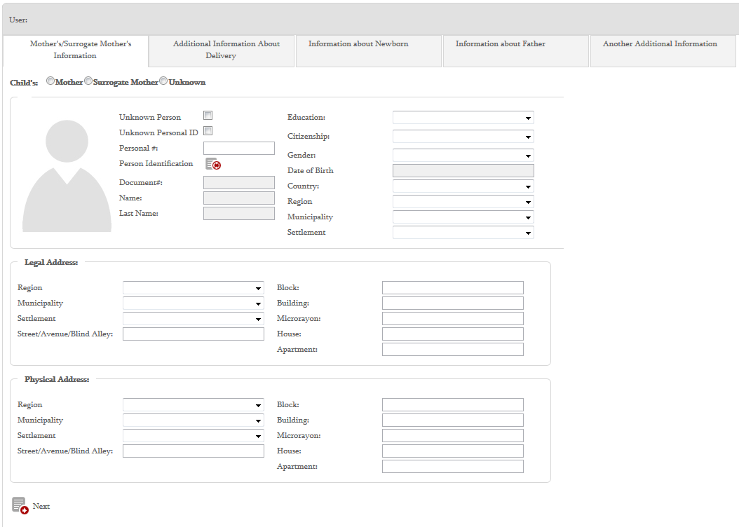

  - Information about Mother/Surrogate Mother
In the subcategory - Information about Mother/Surrogate Mother the user selects the person to identify the child: newborn’s mother, surrogate mother or the person is unknown:
The next step is to enter mother’s/surrogate mother’s personal identification number (PIN) and click on the synchronization button - to identify the person using the electronic service of the Service Development Agency (SDA). Accordingly, the person’s first name, second name, gender, date of birth and photo fields are automatically completed. The user can change the person’s gender if the one received from the SDA does not coincide with the real gender. Information about education and place of birth (country, region, municipality and settlement) is added by the user using the drop-down list (Fig. 5).

Figure 5
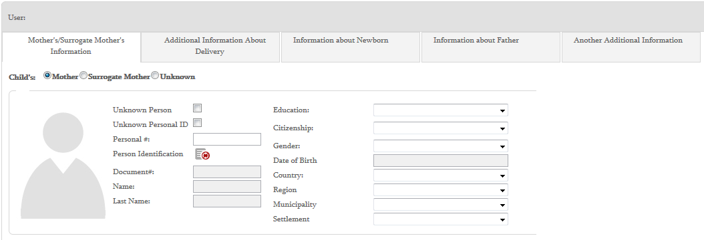
If mother or surrogate mother cannot be identified by PIN, select the field – Unknown Personal ID and the system will automatically assign a temporal unique code to the patient. The user fills out First Name and Second Name fields manually.

If mother or surrogate mother is unidentified, the user selects the field – Unknown Person.
The user fills out address fields (legal and physical addresses) in sequential order (Fig. 6).

Figure 6
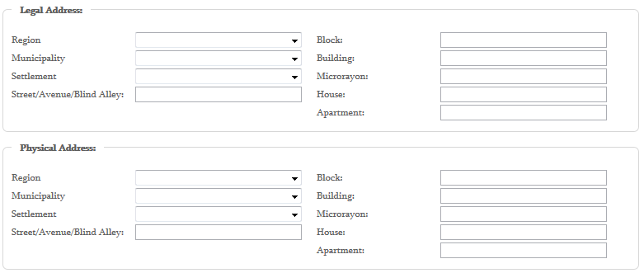

  - Additional Information About Delivery
The user enters the following additional information about delivery into the above-mentioned interface (Fig.6):
- Fetal Number (click on the relevant button to enter the information)
- Total Number of Pregnancies (click on the relevant button to enter the information)
- Number of Live Births (click on the relevant button to enter the information)
- Type of Delivery (select it in the drop-down list)
- Baby Number (click on the relevant button to enter the information)
- Gestational Age (weeks) (manually enter)
- Delivery (the user selects one of the options)
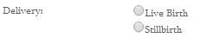
- Marital Status (the user selects one of the options)
- Marriage Certificate # (manually enter)
- Record Number (manually enter)
- Date (date of marriage is selected in the calendar)
- Marriage Registration Place (manually enter)
- Delivery (fetuses) (click on the relevant button to enter the information)

Figure 7
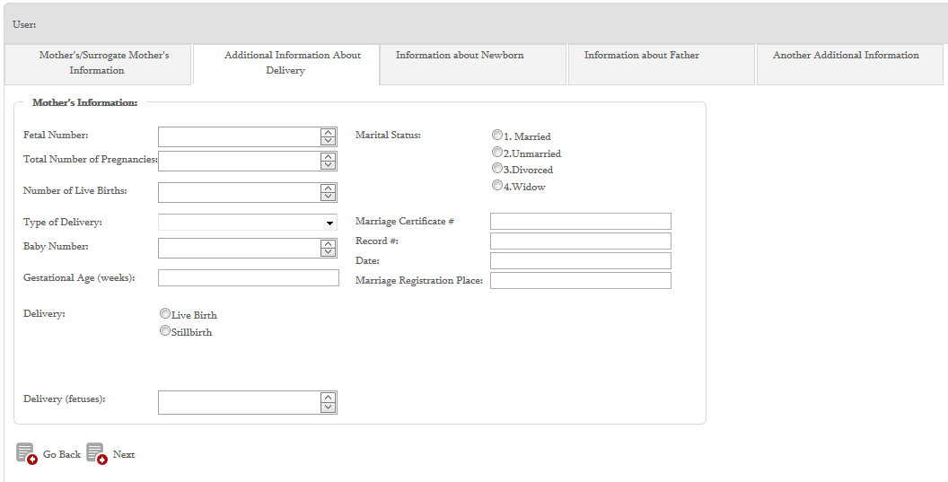

  - Information About Newborn
The user enters the following information about a newborn into the interface: (Fig. 8)
- Giving Last Name (select the relevant option)
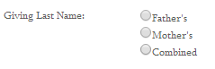
- Apgar Score (click on the relevant button to enter the information)
- Born with a Congenital Anomaly (select the relevant option)
- Child’s Last Name (manually enter)
- Child’s First Name (manually enter)
- Country, Region, Municipality, Settlement (click on the relevant button to enter the information)
- Gender (select the relevant option)
- Weight (manually enter grams)
- Length (manually enter centimeters)
- Delivery Time and Date, Place fo Delivery (click on the relevant button to enter the information)
- Child’s Registration Address (select mother’s or father’s address. In case of another address, enter the information manually)
- Country, Address, Region, Municipality and Settlement (fill out relevant fields)

Figure 8
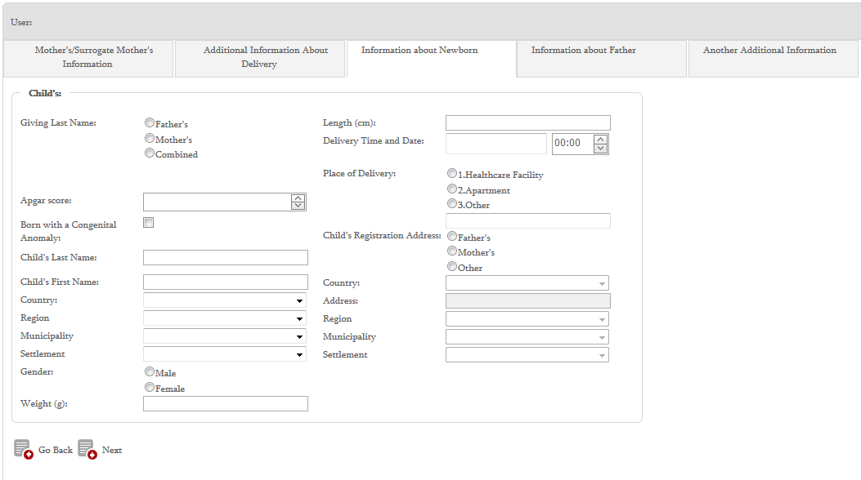

  - Information About Father
Enter information about father in the same way as the information about mother. Click on the synchronization button to identify father and most of the fields will automatically be filled out using the electronic service of the SDA. Additional fields, such as Education, Place of Birth and Physical Address are filled out by clicking on relevant buttons (Fig. 9).
Figure 9
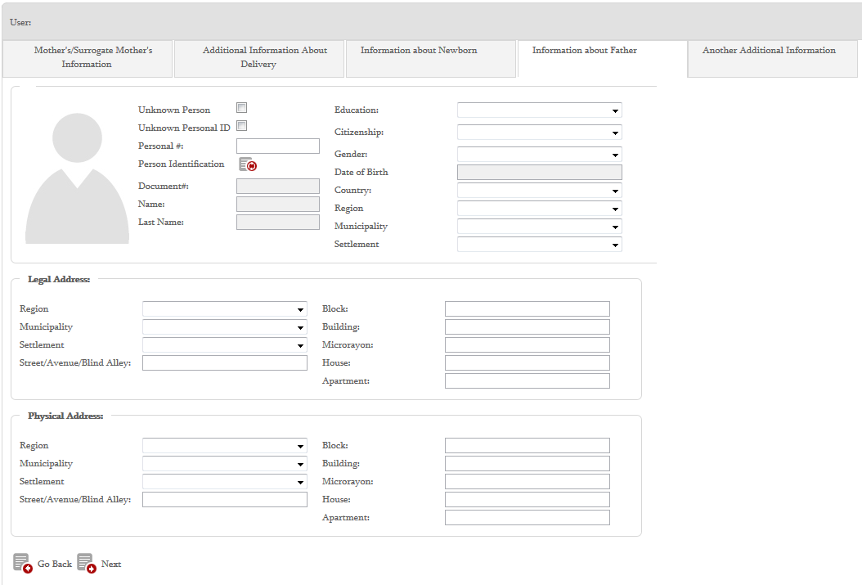

  - Additional Informaiton
Under this subcategory the user fills out additional information fields, such as mother’s telephone number, language for notification (Georgian, Rusiian, Armenian or Azerbaijani) and selects the undersigned party (mother, father and two legal representatives, witnesses of child’s birth). If the user selects the legal representative, s/he must be identified by PIN using the electronic service of the DSA (Fig. 10).

Figure 10
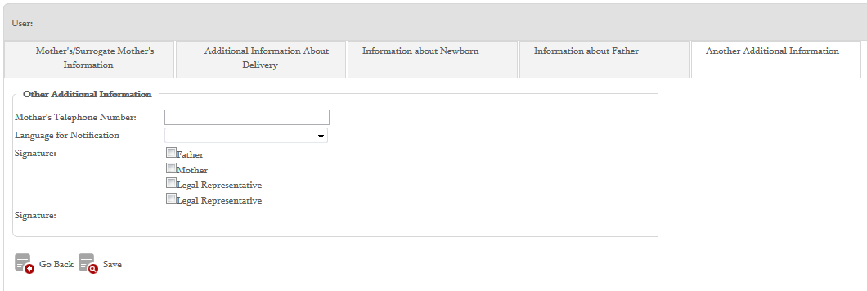
After filling out all subcategories click on the 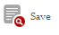 button to save the information in the database.

Death Certificate
This category includes the following subcategories (Fig. 11):
- Information about Deceased Person
- Information about Death
- Information about Causes of Death
- Information on Pregnancy during the Last 12 Months (this subcategory opens only if the dead person is female)
- Information about Children Dead before the Age of 5 (this subcategory opens only if the dead person is not above 5 years of age)
- Information on Conclusion of Death

Figure 11
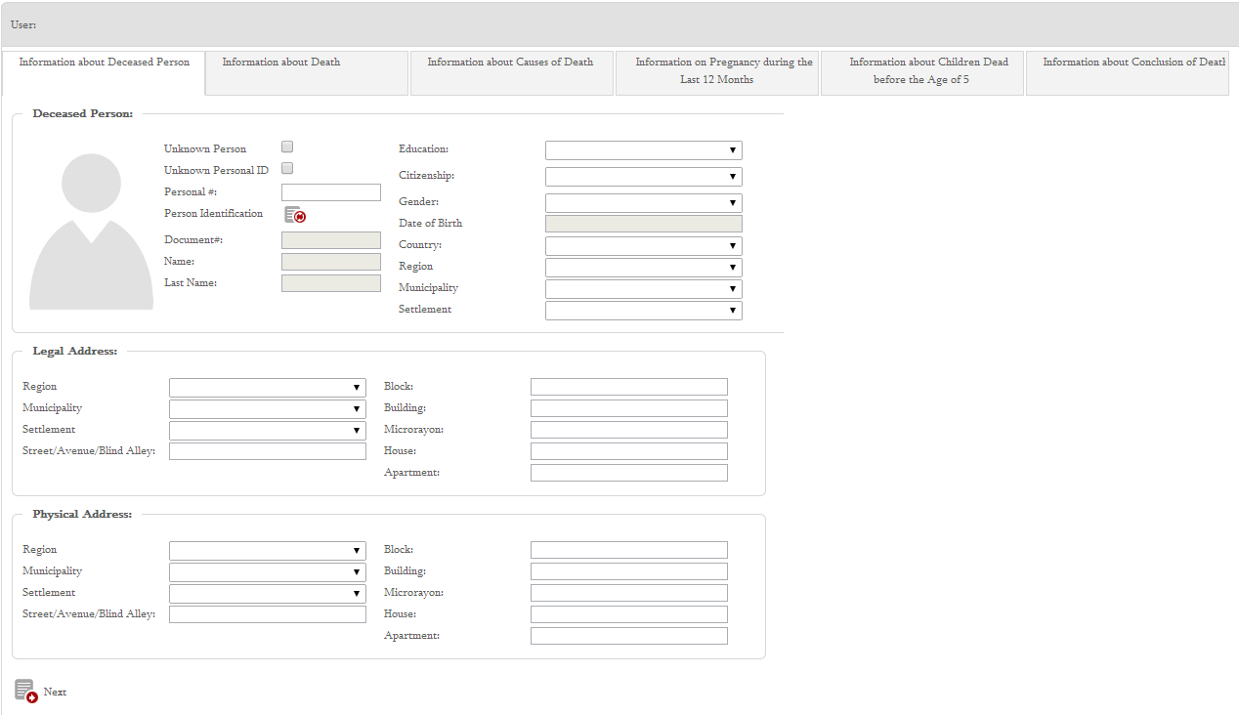

  - Information About Deceased Person
In this subcategory the user fills out the deceased person’s PIN. S/he clicks on the synchronization button () to identify the person using the electronic service of the SDA. Accordingly, the person’s first name, second name, gender, date of birth and photo fields are automatically completed. The user can change the person’s gender if the one received from the SDA does not coincide with the real gender. Place of birth (country, region, municipality and settlement) fields are completed by the user in the drop-down list (Fig. 12).

Figure 12
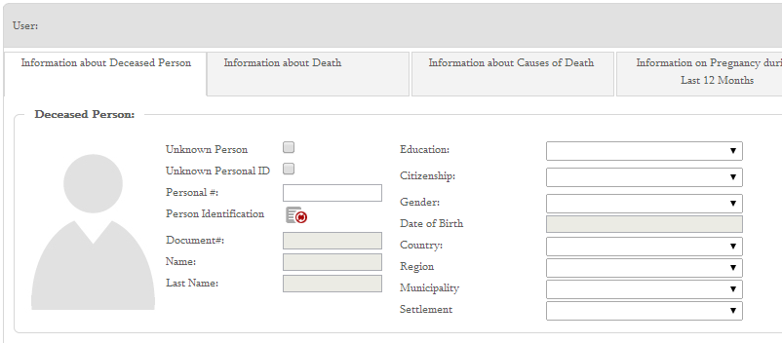
If the deceased person cannot be identified by PIN, select the field – Unknown Personal ID and the system will automatically assign a temporal unique code to the patient.

The user fills out address fields (legal and physical addresses) in sequential order (Fig. 13).
Figure 13
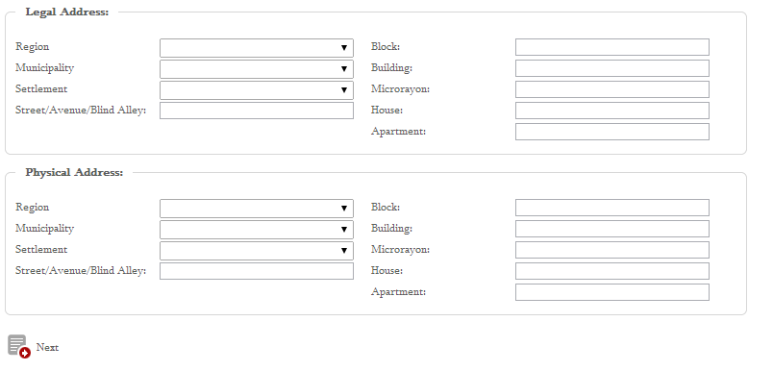

  - Information About Death
The user enters the following information about death of the person into this interface (Fig. 14):
- Date/Time of Death (click on the relevant button to enter the information)
- Notification Date (date is selected in the calendar)
- Place of Death (select the relevant option. Indicate the place of death if you select “Other”)
- Country (select the country in the drop-down list if death occurred in another country)
- Address (manually enter if death occurred in another country)
- Region, Municipality and Settlement (select it in the drop-down list)
- Source of Entering Deceased Person’s Personal Data (textually enter)
- Marital Status: married, unmarried, divorced or widow/er (select the relevant option)
Figure 14
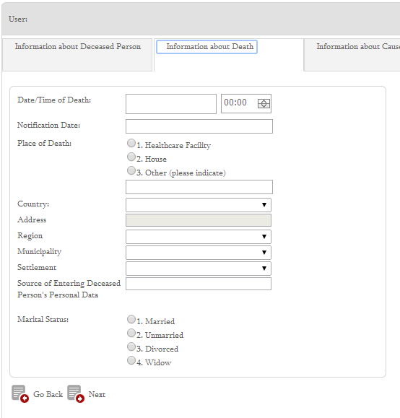
  - Information About Causes of Death
On the interface the user adds Internatioanl Classification of Diseases (ICD) 10 codes - causes of death to the first column (Fig. 15) and ICD10 codes that hastened death - to the second column by clicking on the relevant buttons -.
Figure 15
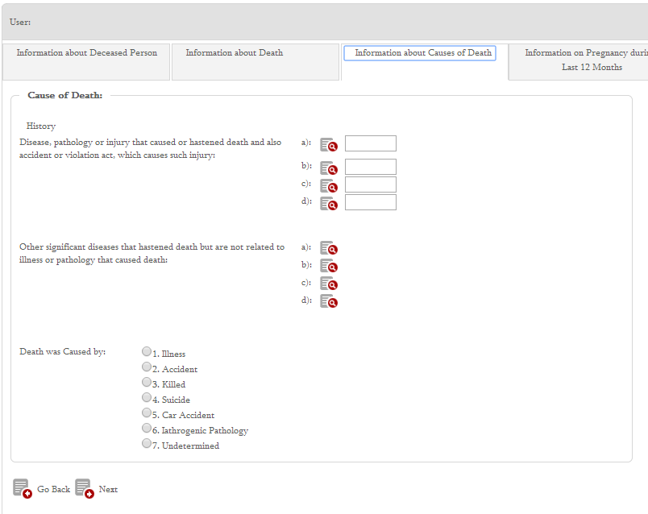
The user clicks on the search () button to open a windwow where s/he determines the parameter to search for the relevant diagnosis: full code, Georgian and/or English name. The user enters one symbol or a combination of letters, clicks on the search button and selects the relevant diagnoses among the options (Fig. 16). S/he clicks on the Save button to add the selected diagnosis to the list of causes of death. As soon as the saved diagnosis appears on the interface, a user indicates the duration of that disease/condition in the field along the same line.

If the user does not search for diagnosis by code or name and tries to find it in the list, s/he must open the code and select the relevant one. If the user selects a code related to trauma an additional list of causes of trauma appears.
Figure16
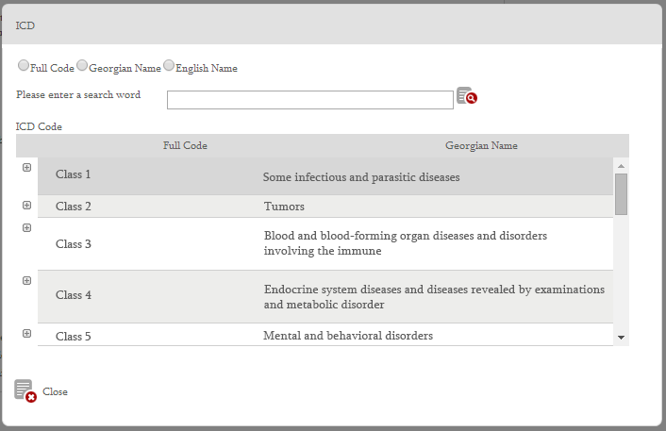
In case of several causes of death the user can also oadd other diagnosis. S/he can delete the added code by clicking on the relevant button - 

In case user selects trauma related codes, e.g. T05, additional list of selectable options appear that enables indication of circusmtances when/where this trauma happened (fig 17).

Figure 17
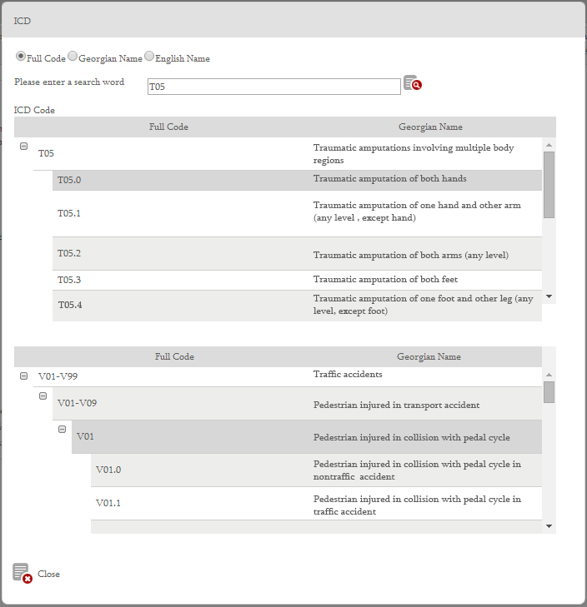

After selecting ICD codes – causes of death and ICD codes that hastened death the user must select the relevant option (Fig. 18):

Figure 18
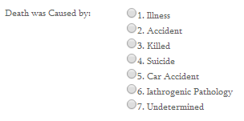

If the user selects “Killed”, additional subcategory “Forced Death” will automatically be added to the category of Death Certificate (Fig. 19). The user selects the venue where death occurred and then - place and circumstance.
Figure 19
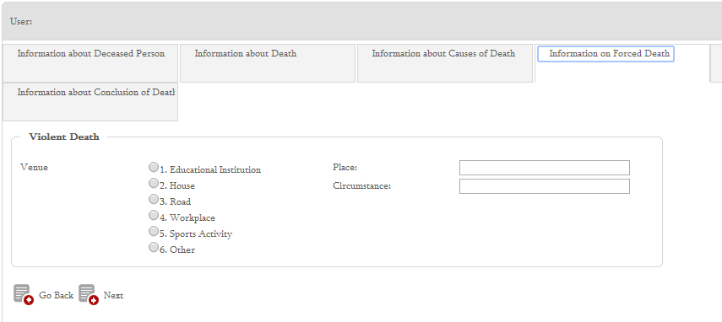

  - Information on Pregnancy during the Last 12 Months
This subcategory appears only if the dead person is female. First of all, the user determines if the dead person was pregnancy during the last 12 months.
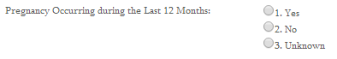
If the answer is “no” or unknown, the user moves to the next subcategory. If the answer is “yes”, the following additional fields appear (Fig. 20):
- Pregnancy Status - (select the relevant option: pregnancy at death, pregnancy during the last 42 days or pregnancy that occurred during the last 43 days-1year.)
- Gestational Age – indicate the gestational age at death. If the information is not known, select “Unknown”.
- Pregnancy Due Date – date is selected in the calendar
- Death Related to: select the relevant option: complicaiton of abortion, complication of ectopic pregnancy, pregnancy complication, complication of delivery, postpartum complication (through the 42nd day) or other. Indicate other cause of death if you select “Other”.
Figure 20
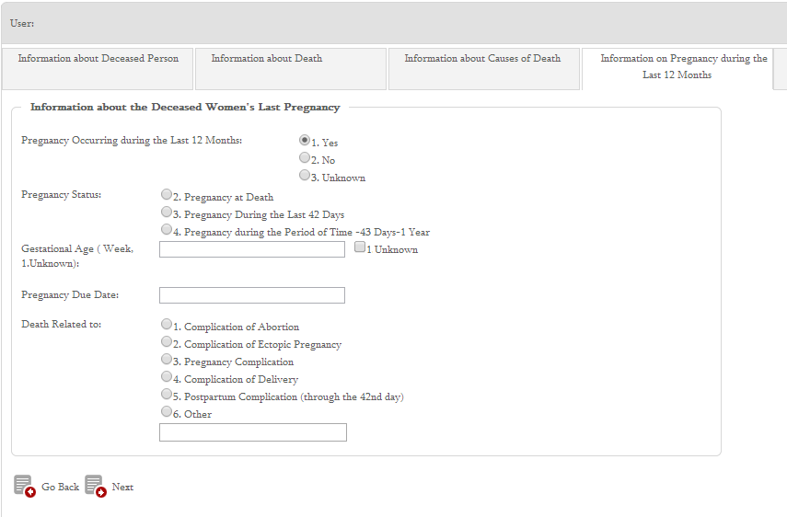

  - Information about Children Dead before the Age of 5
This subcategory appears only if the deceased person is not above 5 years of age (Fig. 21). Accordingly, the user must determine the following:
- Age at Death – determine the dead child’s age
- Delivery – determine fetal number
- Birth Weight – select birth weight
- Birth Length – select birth length
- Delivery Time- select relevant time
- Gestational Age (weeks) - determine gestational age at child’s death

Figure 21
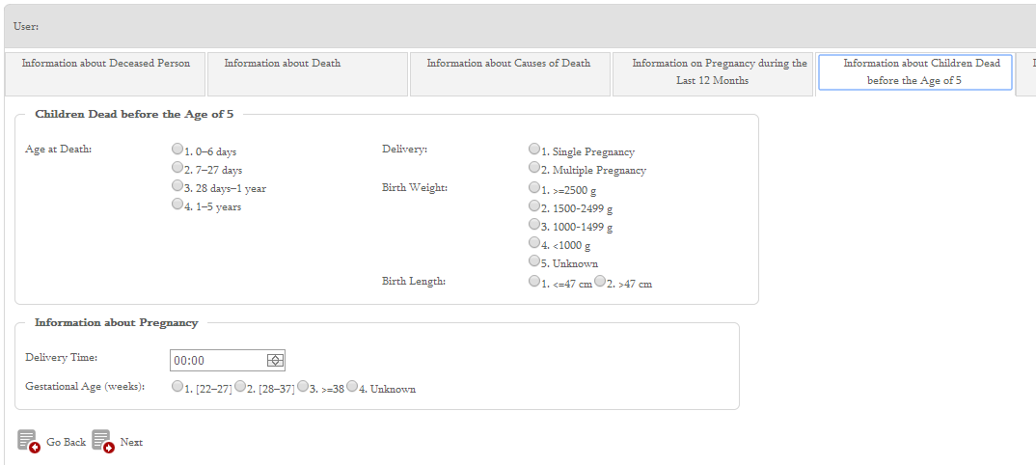

  - Information about Conclusion of Death
The user identifies the person who confirms death and registers additional information in this subcategory (Fig. 22):

Figure 22
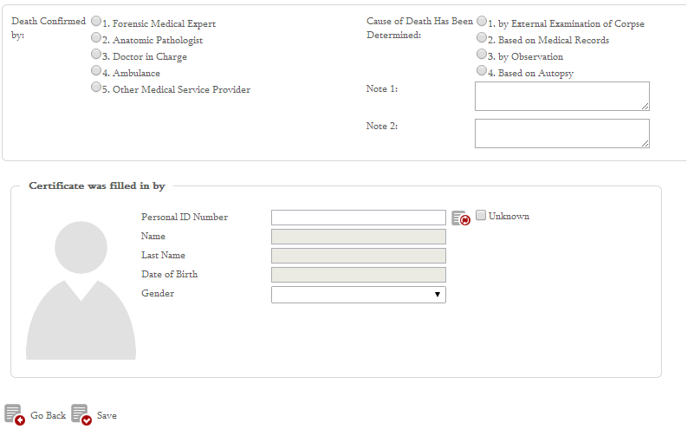
- Death Confirmed by – death may be confirmed by a forensic medical expert, anatomic pathologist, doctor in charge, ambulance and other medical service provider. The user identifies the relevant person.
- Cause of Death Has Been Determined – the user selects the relevant option.
- Notes – the user can enter significant additional information into the fields.
- Certificate was filled in by –the user identifies the person who filled in the death certificate by using the electronic service of the SDA. S/he enters the person’s PIN and clicks on the synchronization button. First name, second name and date of birth fields will automatically be filled out. If the person cannot be identified, the user selects “Unknown” and manually enters first name, second name, date of birth, etc.
After completion of all categories, the user clicks on the button to save information in the database.

List of Deceased Persons
In the category - List of Deceased Persons the user can find registered deceased persons and view a complete list of deceased persons.
Deceased persons can be found using the following filters (Fig. 23):
- Personal ID Number
- First Name
- Last Name
- Gender
- Date of Birth From - To (the date is selected in the calendar)
- Dates of Death and Case Registration (the date is selected in the calendar)

Figure 23
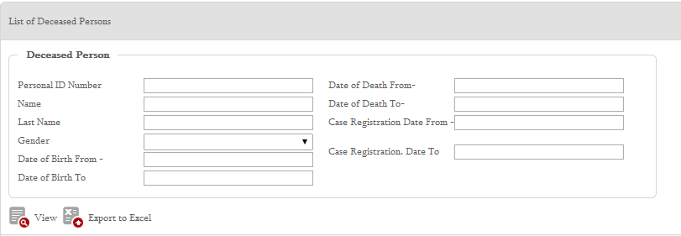

If the user does not indicate different parameters in the filter, information on all registered persons will be displayed in search results: the deceased person’s PIN, first name, second name, gender, date of birth, date of death and case registration date (Fig. 24). The user can ieasily group the data by dragging up and droping a relevant column.

Figure 24
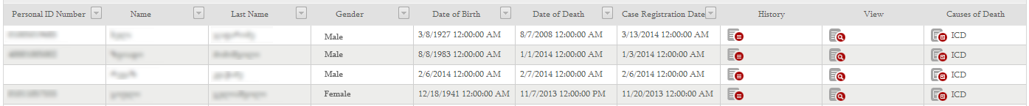

The user can click on buttons next to the deceased person displayed in search results to :
- view the deceased person’s medical history and registered diagnosis that is especially helpful when the cause of death is unknown i.e. until it is edited and added (Fig. 25).
- view the deceased person’s death certificate including all the necessary data that can be found on the death certificate interface.
- view ICD10 codes –registered causes of death (Fig. 26).

Figure 25
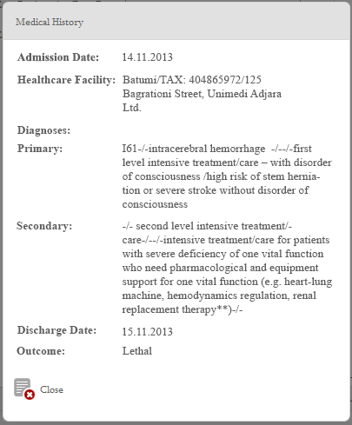

Figure 26

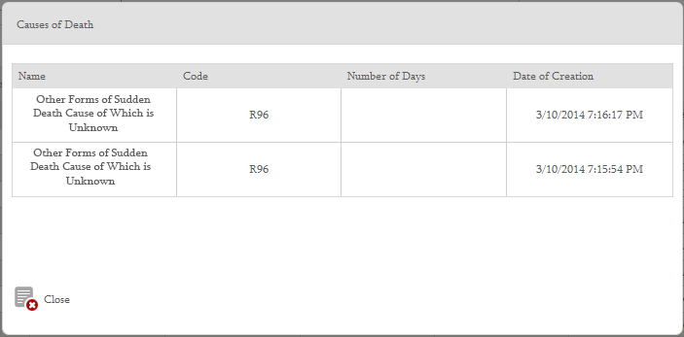

The user can click on the button to export filtered information to Excel to make many-sided analysis.

List of Newborns
In the category - List of newborns the user can find a newborn registered in the system and view a complete list of registered newborns.

Newborns can be found by using the following filters (Fig. 27):
- First Name
- Last Name
- Gender
- Date of Birth From - To
- Length
- Weight
Figure 27
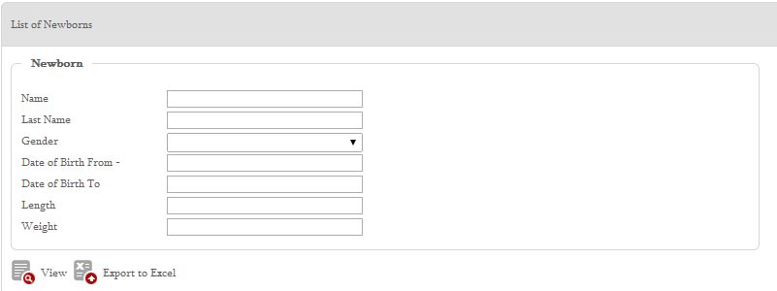

If the user does not indicate different parameters in the filter, information on all registered newborns will be displayed in search results: first name, second name, gender, date of birth, length and weight (Fig. 28).

Figure 28

The user can click on the button next to the newborn displayed in search results to view and edit information about him/her.

The user can click on the button to export filtered information to Excel to make many-sided analysis.

